**17MIS1139**

**S.SOWMIYA**

**Virtual Lab**

**Exercise – 7**

1. **Apply echo on debug and print the values of the variables in the sample programs given**

**Program:1**

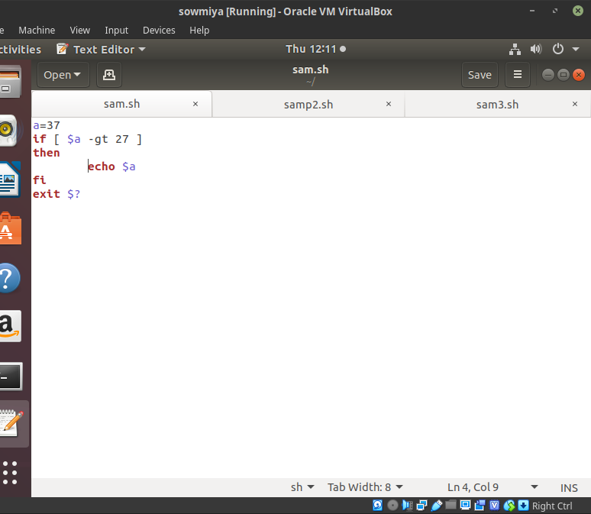

**Output:**

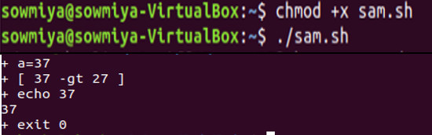

**Program:2**

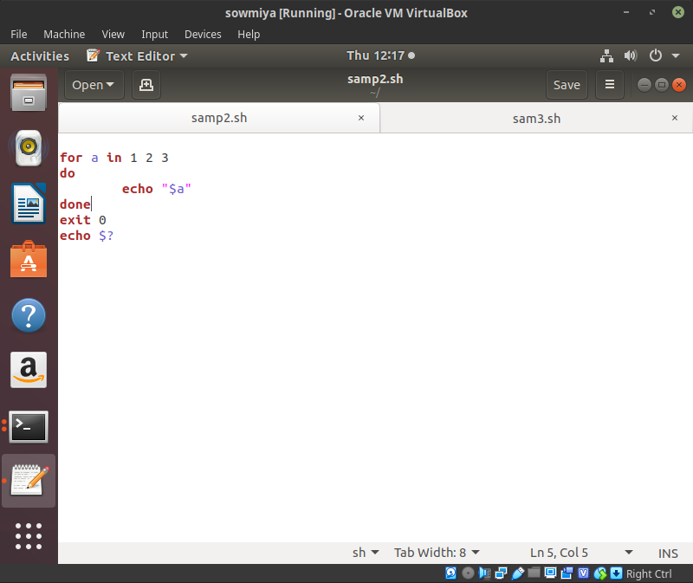

**Output:**

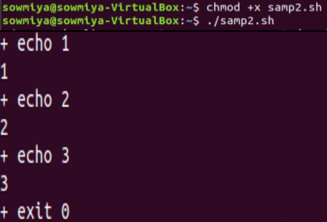

**Program:3**

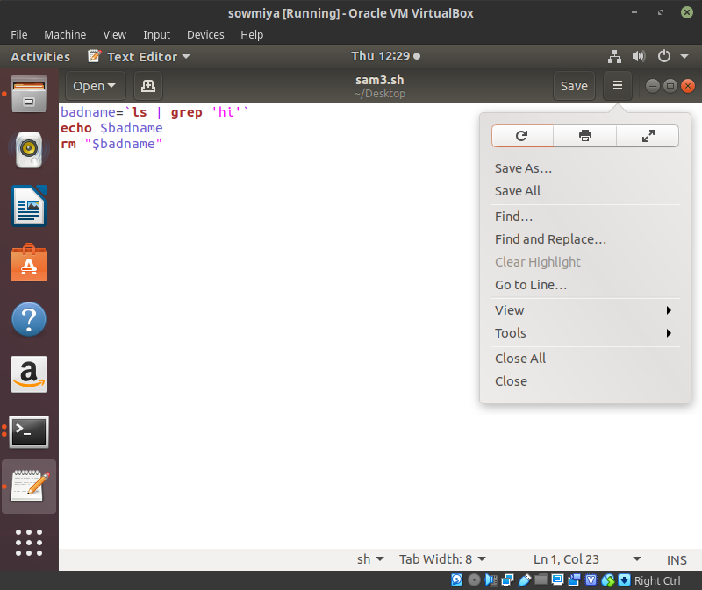

**Output:**

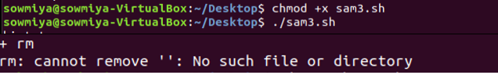

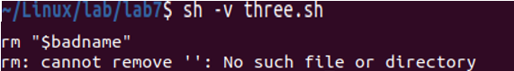

1. **Use tee command**

**Code:**

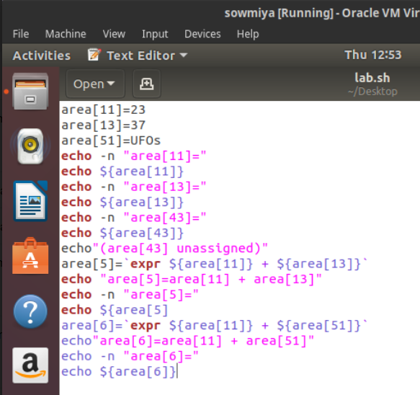

**Output:**

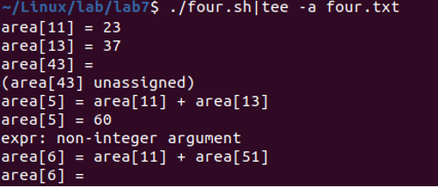

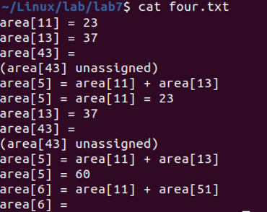

**3. Script Flag options**

sh -n scriptname checks syntax errors

sh -v scriptname echoes each command before executing it

sh -x scriptname echoes the result each command, but in an abbreviated manner

1. **Program:1**



**Output:**

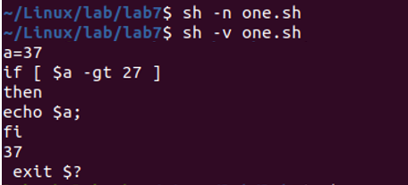

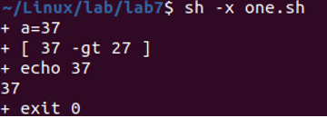

1. **Program:2**



**Output:**

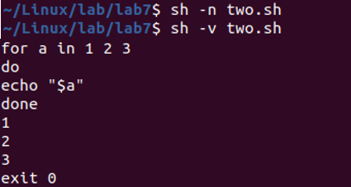



**iii) Program:3**



**Output:**

